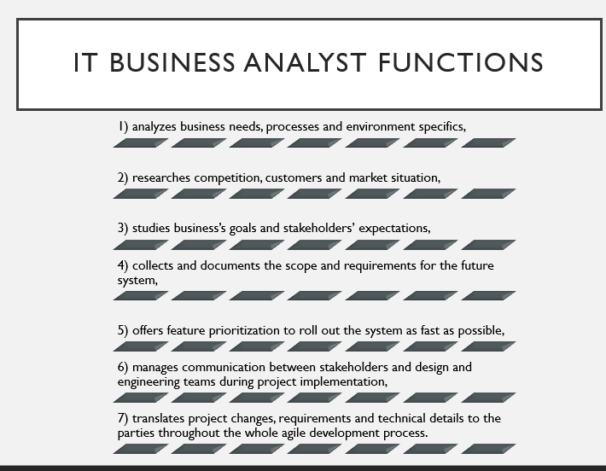

Hi, everyone. For those of you who don’t know me, my name is Vlad Shorin.

You can see a list of main functions on the desk. This is a non-exclusive list. Traditionally, business analyst has a lot on the plate, including a long list of documents to prepare before the project kicks off. Usually, it takes weeks if not months to complete the analysis.

In the agile development, however, an IT business analyst needs to speed up and help roll out the project as soon as possible. Iterative project development implies that the teams and stakeholders get the results fast, test the first versions of a software product and quickly adapt to changing requirements.

Therefore, in these conditions, analysts should choose the most suitable business analysis techniques among the dozens of existing ones.

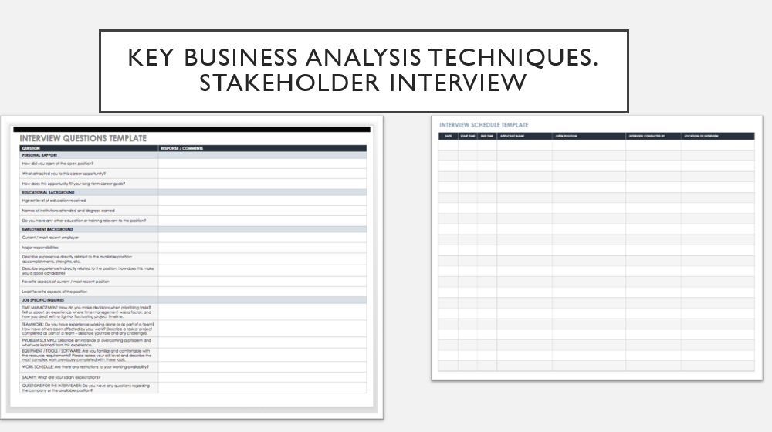

The first and the main technique is stakeholder interview.

This technique implies one or more Q&A sessions with the key decision makers and domain experts.

At this stage, we can study the client’s major business goals, motivation and scope of the project, learn what stakeholders know about their users, competitors, market situation.

As a result, conducting one or more interviews enables better understanding of the client’s goals, future system users, infrastructure and market environment, as well as technological capabilities.

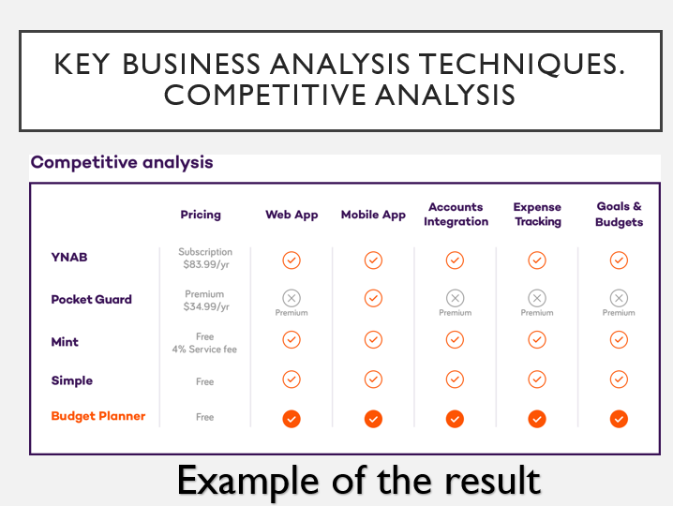

The second key technique is competitive analysis.

Competitive analysis or audit is a great business analysis technique to get more knowledge about the client’s domain, market and the existing solutions that solve similar tasks the future system should deal with.

At this stage, we create a list of existing and potential competitors, both direct and indirect ones. For this purpose, we use the data from stakeholder interviews, online search and keyword analysis, “zoom out” to related markets for similar solutions. Then, we define assessment criteria and perform the analysis of the competitors’ systems - consider main and domain-specific features, systems’ strengths and weaknesses, content, brand-related and technical aspects, user journeys.

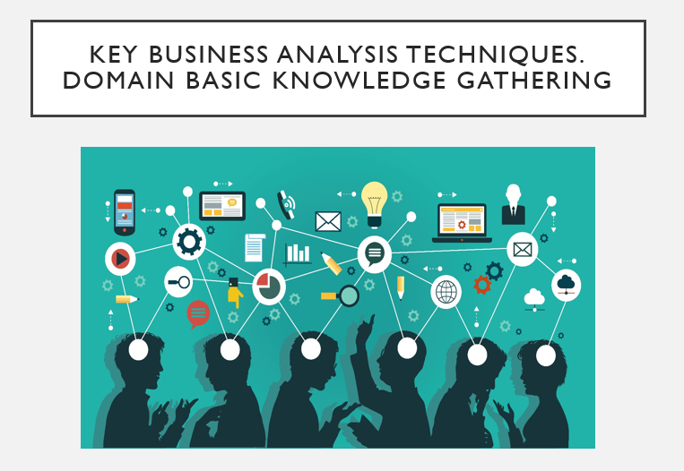

One more popular technique is Domain basic knowledge gathering.

At this stage, we perform an in-depth domain analysis using search, related articles and other domain-specific materials, consult with the stakeholders to get a better view of the client’s environment.

In particular, an IT business analyst studies functional domain specifics, for example, how things work in a certain field - finances, eCommerce, hospitality, etc. At the same time, a tech-savvy analyst gathers data on technical domain specifics - what technologies, frameworks, platforms, data solutions and other digital tools are typically used in a certain industry.

As a result, this information allows to better articulate requirements and choose relevant tools and services for the future system development